What is Block chain?

In today’s digital world, one technology that is transforming finance, security, and the internet is Block chain It is the foundation behind digital currencies and many decentralized systems. But what exactly is block chain, and why is it so important? Let’s understand it in simple words.

Understanding the Meaning of Block chain
As the name suggests, a block chain is a chain of blocks. Each block stores information, and these blocks are connected together in a sequence to form a chain. Every block contains data, and once it is added to the chain, it becomes very difficult to change or tamper with the information stored inside it.

This technology was first described in 1991 by a group of researchers who wanted to create a system that could securely timestamp digital documents. The goal was to make sure that documents could not be backdated or altered. However, the idea did not gain widespread attention until 2009, when
Satoshi nakamoto used it as the core technology for the crypto currency Bit coin.

Block chain as a Distributed Ledger
A block chain works as a distributed ledger, meaning that the data is not stored in one single location. Instead, it is shared across many computers in a network. Because the ledger is distributed, everyone in the network can verify transactions, making the system transparent and trustworthy.

One of the most important features of block chain is that once data is recorded in a block and added to the chain, it becomes extremely difficult to change. This ensures the security and integrity of the information.

Structure of a Block
Each block in a block chain contains several important components:

Data – This includes the information stored in the block, such as transaction details. 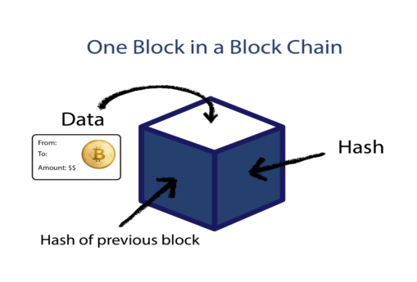

Hash – A unique digital fingerprint that identifies the block.

Previous Block Hash – This links the block to the previous one, creating a chain.
Because every block contains the hash of the previous block, all blocks are connected together. If someone tries to change the data in a block, its hash will change, breaking the chain and alerting the network.

How the Block chain Works?

When a new block is created, it is added to the existing chain of blocks. Each block points to the previous block using its hash, which forms a continuous and secure chain of information. This structure ensures that the entire block chain remains secure and tamper-resistant.

Example of Block chain in Real Life
One of the most well-known applications of block chain is Bit coin. In the Bit coin block chain, blocks store information about transactions, such as the sender, receiver, amount, and time of the transaction. These records are verified by the network and then permanently added to the block chain.

How Block chain Prevents Data Tampering?

One of the most important features of Block chain is that it makes data very difficult to modify or tamper with.
This happens because every block in the chain is connected to the previous block using a cryptographic hash.
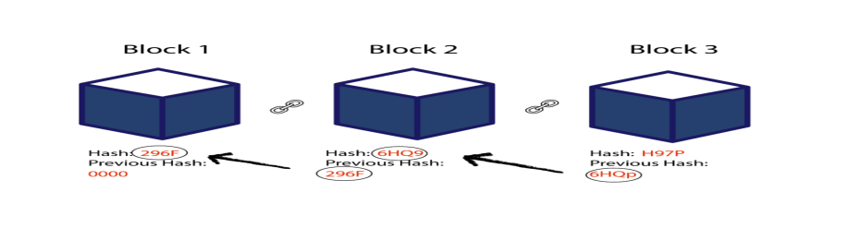
Each block contains: Its own hash
The hash of the previous block The data or transaction information
The first block in a block chain is called the Genesis Block. Since it does not have any previous block before it, its previous hash is usually represented as 0000.
What Happens if Someone Tries to Change a Block?
Suppose someone tries to change the data in the second block of a block chain. When the data inside that block changes, the hash of that block also changes.
Because the next block stores the hash of the previous block, the link between the blocks becomes invalid.

This means:
The second block's hash changes.
The third block still contains the old hash of the second block.

Therefore, the third block becomes invalid.
The same problem spreads to all following blocks in the chain.
As a result, changing even a single block will make all the blocks after it invalid. This is what makes block chain secure.

Why Hashing Alone Is Not Enough
Modern computers are extremely fast and can calculate thousands or even millions of hashes per second. In theory, a powerful attacker could change a block and recalculate all the hashes of the following blocks to make the chain valid again.
To prevent this problem, block chain uses a special security mechanism called Proof of Work.

Proof of Work
Proof of Work is a mechanism that slows down the creation of new blocks and makes tampering extremely difficult. In order to add a new block to the block chain, computers must solve a complex mathematical puzzle.
This process requires a large amount of computational power and time. For example, in the case of Bit coin, it takes approximately 10 minutes to calculate the required proof of work for a new block.
Because of this delay and the computational effort required, changing a block and recalculating all the following blocks becomes practically impossible.

How New Blocks Are Added and Secured in Block chain?

In a Block chain network, new blocks are continuously added to the chain. However, the system is designed in such a way that it becomes extremely difficult for anyone to tamper with the data stored inside the blocks.

This security mainly comes from two mechanisms: hashing and Proof of Work.
When someone tries to change or tamper with a block, they must recalculate the Proof of Work for that block and all the blocks that follow it. Since this process requires huge computational power, it becomes nearly impossible for an attacker to modify the block chain.
Decentralization in Block chain

Another important feature that makes block chain secure is decentralization. Instead of being controlled by a single central authority, block chain is managed by a peer-to-peer network of computers.

In this network:
Anyone can join the system.
Each participant is called a node.
Every node keeps a complete copy of the block chain.
Because many nodes maintain the same data, the system becomes transparent and highly reliable.

How Nodes Verify a New Block
When a new block is created, it is broadcast to all nodes in the network. Each node then verifies the block to make sure that the data inside it has not been tampered with.
If everything is correct:

The node adds the block to its own copy of the block chain.
Other nodes do the same.

This process creates consensus, meaning all nodes agree on which blocks are valid.
If a block is altered or contains incorrect data, other nodes in the network will reject it, preventing the tampered block from being added to the chain.

The 51% Problem
For someone to successfully tamper with a block chain, they would need to:
Change the data in a block
Recalculate the Proof of Work for that block and all following blocks
Gain control of more than 50% of the network nodes
Only if they control the majority of the network could their altered version of the block chain be accepted by others. This situation is known as a 51% attack.
However, in large block chain networks like Bit coin, achieving this level of control is extremely difficult and expensive. Because of this, block chain is considered a very secure technology.

Smart Contracts and Future Applications of Block chain
Another powerful concept in Block chain technology is the idea of smart contracts. These contracts are simple programs that are stored directly on the block chain.

A smart contract automatically executes when certain conditions are met. For example, it can automatically transfer or exchange digital coins between two people once a predefined rule is satisfied. Because the contract runs on the block chain, it does not require a middleman or third party.

Smart contracts make digital transactions faster, more transparent, and more secure .Growing Interest in Block chain After the introduction of block chain technology through Bit coin, interest in this technology grew rapidly. At first, many people only associated block chain with crypto currencies. However, over time developers and researchers realized that block chain could be used for many other purposes beyond digital money.

Today, block chain technology is being explored in several important areas. Real-World Applications of Block chain
Some of the potential applications of block chain include:
- Secure storage of medical records
- Digital identity verification
- Creating a digital notary system
- Supply chain tracking
- Voting systems
- Secure financial transactions
Because block chain records cannot easily be changed, it is very useful in systems where trust, transparency, and data security are important.

